FORMULIR PENGAJUAN PROGRAM PENGHARGAAN SITASI ARTIKEL ILMIAH PADA JURNAL INTERNASIONAL

YANG TERINDEKS OLEH DATABASE INTERNASIONAL BEREPUTASI 2020

|  |  |  |
| --- | --- | --- |
| Nama lengkap dan Gelar | : |  |
| NIP / NIDN | : |  |
| Departemen/Fakultas | : |  |
| Email | : |  |

*(Lampirkan Screenshot dari Citation overview pada profil Author di Scopus dengan exclude self citations)*

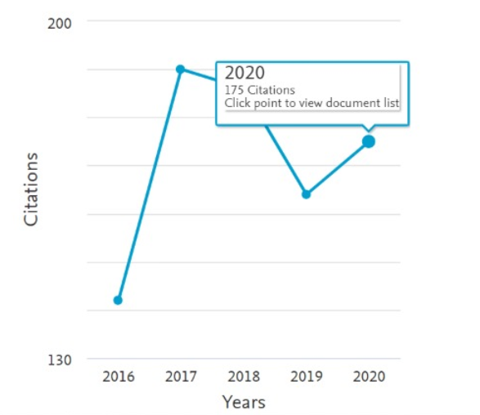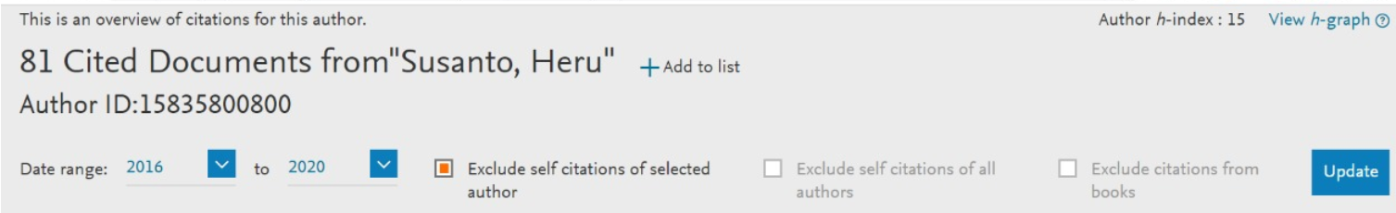

*Contoh:*

**Contoh Tabel Daftar Sitasi Artikel Ilmiah dalam jurnal dan prosiding terindeks SCOPUS**

|  |  |  |  |  |
| --- | --- | --- | --- | --- |
| No | Judul Artikel Yang Disitasi | Penulis | Nama Jurnal/Tahun Publikasi | Artikel Yang Menyitasi |
| 1 | Drying rate and product quality evaluation of roselle (*Hibiscus sabdariffa* L.) calyces extract dried with foaming agent under different temperatures | Djaeni, M., **Kumoro, A.C.,** Sasongko, S.B., Utari, F. D | International Journal of Food Science (2018), Volume 2018, Article number 9243549 | 1. Sasongko, S.B., Utari, F.D. (2019). Kinetic of anthocyanin degradation in roselle extract dried with foaming agent at different temperatures, **Bulletin of Chemical Reaction Engineering & Catalysis,** 14(2), 320-325 |
| 2 | Incorporation of microalgae and seaweed in instant fried wheat noodles manufacturing: Nutrition and culinary properties study | **Kumoro A.C**., Johnny D., Alfilovita D. | International Food Research Journal (2016), (2) 715-722 | 1. Sahni, P., Aggarwal, P., Sharma, S., Singh, B. (2019), Nuances of microalgal technology in food and nutraceuticals: a review, **Nutrition and Food Science**, 49(5), pp. 866-885 2. Shannon, E., Abu-Ghannam, N. (2019), Seaweeds as nutraceuticals for health and nutrition, **Phycologia,** 58(5), pp. 563-577 3. Huang, M., Yang, H. (2019), Eucheuma powder as a partial flour replacement and its effect on the properties of sponge cake, **LWT Food Science and Technology**, 110, pp. 262-268 4. dst…. |
| 3 |  |  |  | 6. |
| dst |  |  |  | 7. dst.. |
|  |  |  |  | Jumlah Total Sitasi: XX **sitasi** |

Semarang, November 2020

Yang mengusulkan,

Ttd

**Nama Pengusul**

NIP